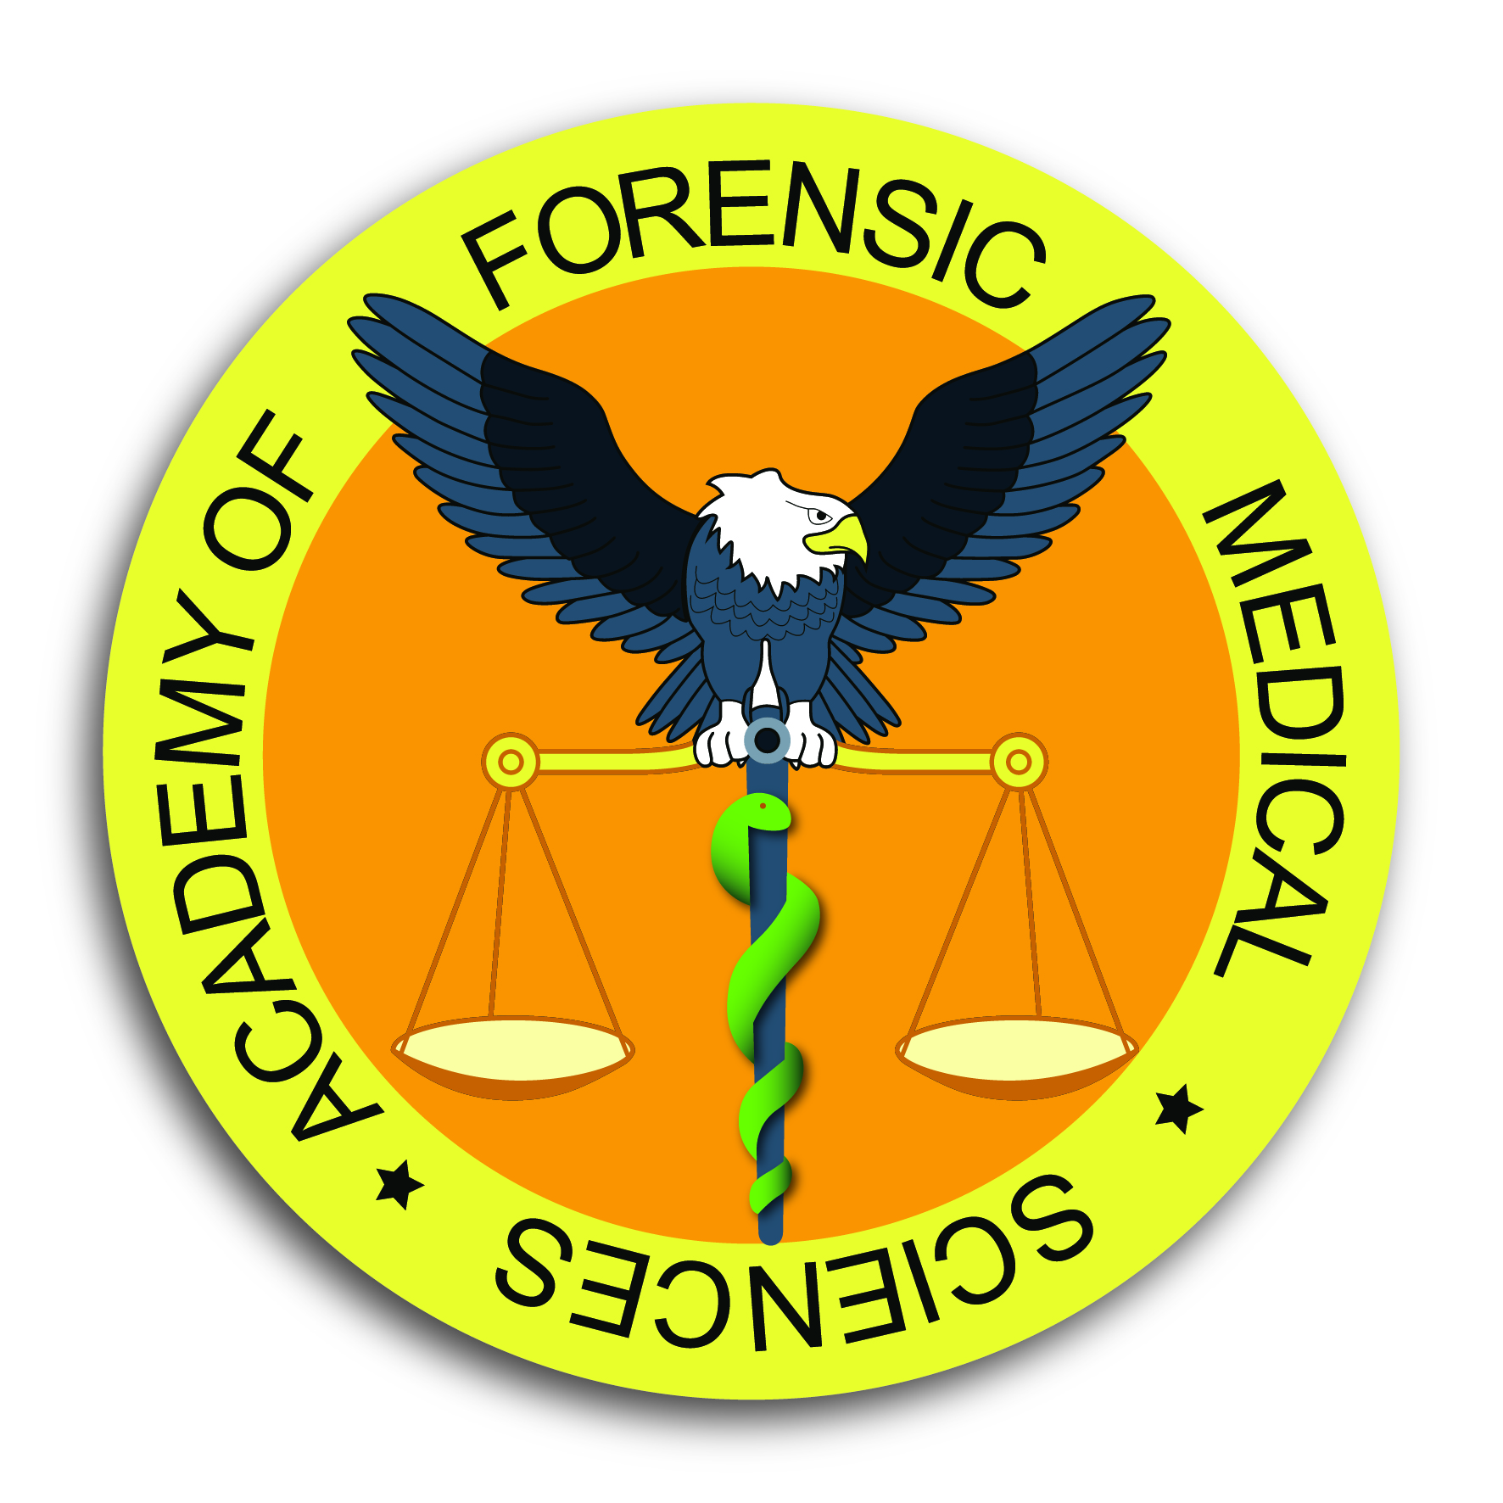
Diploma Course in Forensic Medical Sciences
Application Form
October 2018 – March 2019

First Name(s):
Surname:
Title: Sex: Female / Male
Date of Birth: Nationality:
Correspondence Address:
Town:
Postcode: Country:
Telephone: Email:
Occupation:
Line Manager:
Employment Address (if different to correspondence address):
Town: Postcode:
Telephone: Email:

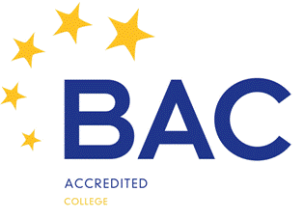

Application Form continued

Degrees or other professional qualifications held
Degree / Qualification |  |  | Awarding Body | Date
Name, address and email of two persons qualified and willing to comment on your academic and / or professional record:
 | Referee 1 |  | Referee 2
Name:
Address:
Email:
Where did you hear of our course:

Signature of applicant
Date
Please return the completed Application Form to:
Mr Adam Konstanciak
Academy of Forensic Medical Sciences
117 Charterhouse Street, London EC1M 6AA
or info@afms.org.uk or via fax: +44(0)207 882 3424
The Course Fee is £900
Your payment will be due once your application had been approved

Full remittance is required prior to commencement of the course

