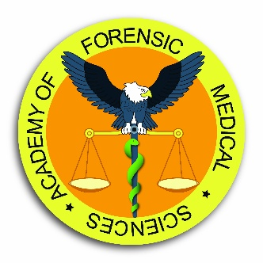
Diploma Course in Forensic Medical Sciences
Distance learning course
Application Form
October 2022 – April 2023

Title ________ | First name(s) ________________________ | Surname _____________________________
Date of birth | ____/_____/________ Nationality: __________________________ Sex: Female / Male
Address | ___________________________________________________________________________________
______________________________________________________________________________________________________
Town: _______________________________________________ Postcode: ___________________________________
Email: | ____________________________________@_____________________________________________
Daytime tel: | ___________________________________________________________________________________
Occupation: | ___________________________________________________________________________________
Line manager: | ___________________________________________________________________________________
Employment Address  (if different to above address) | ___________________________________________________________________________________
 | ___________________________________________________________________________________
 | Town: ______________________________ Postcode: _________________________________
Email: | ____________________________________@_____________________________________________
Telephone nr: | ___________________________________________________________________________________

APPLICATION FORM (CONTINUED)
Degrees or other professional qualifications held
Degree / Qualification |  | Awarding Body |  | Date
________________________________ |  | ________________________________ |  | ________________________________
________________________________ |  | ________________________________ |  | ________________________________
________________________________ |  | ________________________________ |  | ________________________________
Name, address and email of two persons qualified and willing to comment on your academic and / or professional record
 | Referee 1 |  | Referee 2
Name: | __________________________________________ |  | ___________________________________________
Address: | __________________________________________ |  | ___________________________________________
 | __________________________________________ |  | ___________________________________________
 | __________________________________________ |  | ___________________________________________
 | __________________________________________ |  | ___________________________________________
Email: | __________________________________________ |  | ___________________________________________
Where did you hear of our course: ______________________________________________________________

Signature of applicant ________________________________________________
Date ________________________________________________

Please return the completed Application Form to:
Mr Adam Konstanciak
Academy of Forensic Medical Sciences
Miller House, 3 Devonshire Drive, London SE10 8LP
Or via email: info@afms.org.uk
The Course Fee is £950
Your payment will be due once your application had been approved
Full remittance is required prior to commencement of the course

