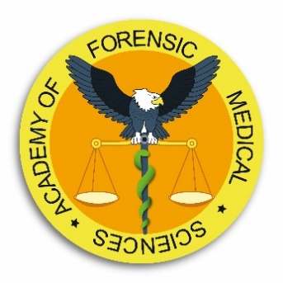

Diploma course in Management of the Dead

03 – 28 July 2023

Lecture 1 | Legal aspects of managing the deceased including bodies from abroad – overview
Lecture 2 | Procedures for the recognition of life extinct, diagnosis of death and considerations for organ donation
Lecture 3 | Exhumation procedure and recovery of deceased legally interred
Lecture 4 | Managing the scene where a body is found
Lecture 5 | Identification procedures – overview of methods and protocols
Lecture 6 | The role of the ICRC in the management of the deceased in armed conflicts
Lecture 7 | Management of multiple deaths and mass disasters
Lecture 8 | Identification in multiple deaths and mass disasters – Identification Commission
Lecture 9 | Dealing with the media
Lecture 10 | Management of a mass grave investigation
Lecture 11 | Identification of deceased from clandestine, single, and mass graves
Lecture 12 | Healthcare environment including care home and hospice
Lecture 13 | The relatives / next of kin and their needs
Lecture 14 | Procedures in the management and use of radiographic (CT, MRI, X-rays) in autopsy practice
Lecture 15 | Medical negligence / complaints cases
Lecture 16 | Special / suspicious / homicide cases
Lecture 17 | Hospital (clinical post-mortem) and non-suspicious coroners cases
Lecture 18 | Paediatric cases
Lecture 19 | Custodial environment
Lecture 20 | Mortuaries: facilities, dealing with high risk cases, and general aspects of health and safety
Lecture 21 | Recovery of the deceased in armed conflicts – the role of the military
Lecture 22 | Role of the funeral director in dealing with the deceased and their families
Lecture 23 | Religious and cultural practices in management of the deceased

