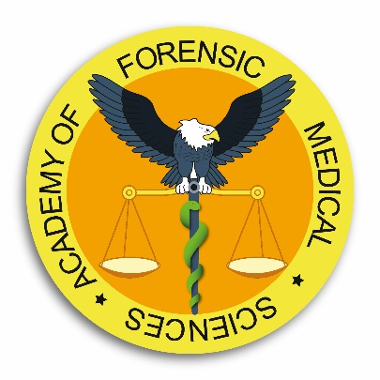

Diploma course in Forensic Medical Sciences

October 2023 – April 2024

Lecture 1 | Bias in Forensic Science
Lecture 2 | Forensic Epidemiology
Lecture 3 | Medico-legal issues and the Doctor
Lecture 4 | Systems of death investigations
Lecture 5 | Adversarial and Inquisitorial judicial systems
Lecture 6 | Role of the Prosecution and role of the Defence
Lecture 7 | Medical negligence
Lecture 8 | Aspects of the female gender
Lecture 9 | Criminal law in Scotland
Lecture 10 | Examination of detainees
Lecture 11 | The process of investigating murder
Lecture 12 | Investigation of sexual offences
Lecture 13 | Fatal accident inquiries
Lecture 14 | Forensic psychiatry
Lecture 15 | The National Child Mortality Database in England
Lecture 16 | The management of major trauma – medico-legal considerations
Lecture 17 | The role of the ICRC in human rights abuses
Lecture 18 | Paediatric clinical forensic medicine
Lecture 19 | Forensic science, human rights and the United Nations: The development of international principles and guidelines for forensic human rights investigations
Lecture 20 | The expert witness
Lecture 21 | The role of the Coroner in death investigation
Lecture 22 | Torture investigation
Lecture 23 | Diagnosing death, recognition of life extinct, organ donations
Lecture 24 | Human tissue retention
Lecture 25 | Ballistics and firearms
Lecture 26 | The forensic autopsy
Lecture 27 | Paediatric forensic medicine
Lecture 28 | Forensic entomology
Lecture 29 | Interpretation of injuries
Lecture 30 | Head injuries
Lecture 31 | Sudden death – natural causes?
Lecture 32 | Pathologist’s role at a crime scene
Lecture 33 | Investigation of sharp force trauma
Lecture 34 | Deaths in custody
Lecture 35 | Crime scene investigation
Lecture 36 | Forensic imaging
Lecture 37 | Asphyxia and related deaths including drowning
Lecture 38 | Fires and explosions – scientific aspects
Lecture 39 | Time of death
Lecture 40 | Deaths due to fires and explosions
Lecture 41 | Forensic science in crime investigation
Lecture 42 | Blood pattern analysis
Lecture 43 | Forensic odontology
Lecture 44 | Forensic DNA analysis
Lecture 45 | Mass disaster management
Lecture 46 | Exhumation
Lecture 47 | Role of anthropology and archaeology in death investigation
Lecture 48 | Forensic ecology
Lecture 49 | Alcohol, drugs and driving
Lecture 50 | Recreational drugs and the law
Lecture 51 | Drugs and poisons: Detection and interpretation
Lecture 52 | Clinical and pathological aspects of alcohol and drug abuse

